**BOARD OF DIRECTORS**

* **TAVARES JONES, EXECUTIVE DIRECTOR**

Tavares Jones serves as the Executive Director of the Miss Miami Gardens Scholarship Program. His experience spans over 10 years within the Miss America Organization, serving as a Certified Judge, Board Member and Co-Executive Director for several local preliminary pageants in Florida, Georgia, Ohio and Arkansas.

Beyond his work with the Miss America Org., Tavares works as a television News Anchor & Journalist at WSVN-TV Channel 7 News, South Florida’s Fox News Affiliate. A graduate of the University of Florida, he holds dual degrees in Broadcast Journalism and Political Science. Tavares also devotes much of his time serving various organizations including the United Way, Children’s Miracle Network, Catholic Charities, and the Ryan White Foundation. Tavares is proud to be a part of and committed to preserving one of our nation’s leading achievement programs and the world’s largest provider of scholarship assistance for young women, the Miss America Organization.

* 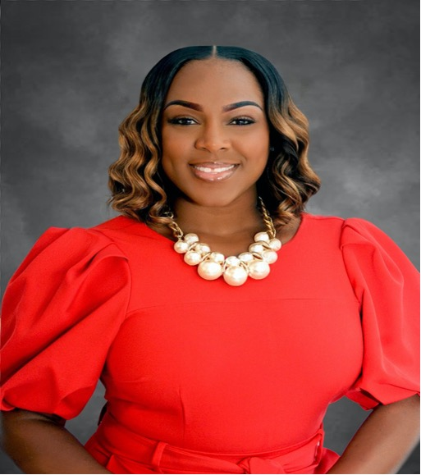**LATOTA PORTER, BOARD MEMBER & DIR. OF DEVELOPMENT**

Latoya Porter serves as the Director of Development for the Miss Miami Gardens Scholarship Program. A native of South Florida, Latoya is an alumnus of the great Florida Memorial University, receiving a Bachelor of Science in Elementary Education and Masters in Reading Education with an ESOL & Reading Endorsement.

As an educator, Latoya serves as the Literacy Coach and Professional Development Liaison at Miami- Dade County Public Schools’ Scott Lake Elementary. Her work and passion for community service goes far beyond the classroom, as she also dedicates her time to various organizations including Top Ladies of Distinction, Inc., Miami-Dade County Public Schools MINT, she’s the Founder & President of Girls Growing into Greatness, Inc., and a proud member of Delta Sigma Theta Sorority, Inc.

**BOARD OF DIRECTORS**

* 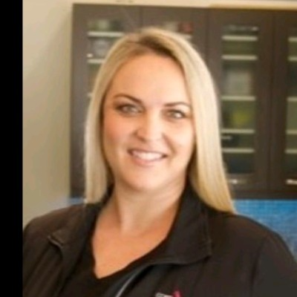**KRISTYN LETTE, BOARD MEMBER & DIR. OF OPERATIONS**

Kristyn Lette serves as the Director of Operations for the Miss Miami Gardens Scholarship Program. Her experience spans over 20 years in various leadership roles consisting of Operations and People Development. Kristyn is passionate about mentoring youth, she’s an anti-bullying advocate and active participant in the South Florida Chapter for The American Foundation for Suicide Prevention’s (AFSP) ‘Walk to Fight Suicide’. Kristyn is also a former contestant & runner up in the Model Search America pageant of Richmond, Virginia. Kristyn is honored to serve as a Board Member for the Miss Miami Gardens Scholarship Program and is excited for all the amazing opportunities the program affords to young women.

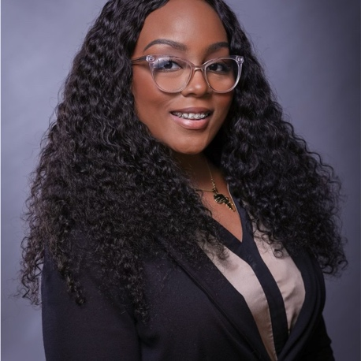

* **LORRAINE WRIGHT, BOARD MEMBER & SCHOLARSHIP CHAIR**

**BIO COMING SOON.**

**BOARD OF DIRECTORS**

* 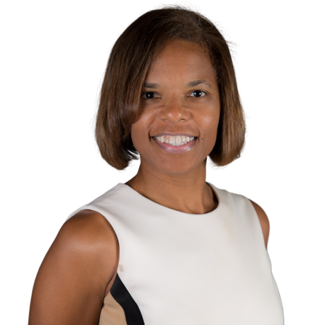**ERIKA BROWN, BOARD MEMBER & JUDGE’S CHAIR**

**BIO COMING SOON.**

* + - * **KATERINA RODRIGUEZ, MARKETING & PUBLIC AFFIARS CHAIR**

Katerina Rodriguez serves as the Marketing and Public Affairs Chair for the Miss Miami Gardens Scholarship Program. Beyond this role, she currently works in television as a News Producer and Journalist at WSVN-TV Channel 7 news, South Florida's Fox News affiliate.

A Broadcast Media graduate of Florida International University, Katerina also attended the University of Florida, and majored in criminology. As native of Miami-Dade County, Katerina works closely with various non-profit organizations specifically focused on educational outreach and “Get Out the Vote”, which include efforts aimed at increasing voter turnout among marginalized groups in South Florida. Katerina has also dedicated several years to coaching high school competitive debate teams and judging competitions across the country.